**Exercise**:

1. Give the path to your directory

/home/dinash12

1. How many entries in:

Your directory: ls –l|wc –l There are 10 entries

ls –la|wc –l There are 26 entries

What is the significance of the:

. (dot) directory: for current directory

.. (double dot- directory: for parent directory

1. Give the number of entries in each of the following directories.

Hint: Answer each of a two step problem.

* **First** move to the directory (using cd path)
* **Second** execute ls –l|wc -l

1. The root directory / 27 entries
2. /bin 162 entries
3. /sbin 163 entries
4. /usr 9 entries
5. /usr/bin 1670 entries
6. /usr/sbin 189 entries
7. How many users current logged onto atlas. The command **“who”** shows who is logged on.

1 user number. users | wc -l command used.

1. Using **cal** Use **man cal** to determine how to find which day of the week you were born.

On which day of the week were you born? Wednesday

1. How can you display a calendar of 2011 on the screen?

Give the command cal 2011

1. Given the following hierarchical structure.

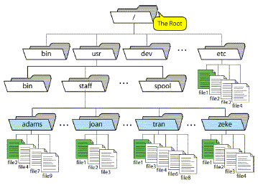

1. Give the absolute path to the **file9**

/usr/staff/adams/file9

1. If the current working directory is **/usr/staff**, give the relative path to **file9**

/adams/file9